**SKY ADVENTURE GAME DESIGN DOCUMENT**

Your Game Logo

Here

***‘Catchy Game Tagline’*** - you

This page: Table of Contents and Team Member Listing

|  |  |  |
| --- | --- | --- |
| Table of Contents  [1 Game Overview](https://n-xovwktmtjsnaxyc2mwes2xu7pohqedmdm6zjw5q-2lu-script.googleusercontent.com/userCodeAppPanel)  [2 High Concept](https://n-xovwktmtjsnaxyc2mwes2xu7pohqedmdm6zjw5q-2lu-script.googleusercontent.com/userCodeAppPanel)  [3 Unique Selling Points](https://n-xovwktmtjsnaxyc2mwes2xu7pohqedmdm6zjw5q-2lu-script.googleusercontent.com/userCodeAppPanel)  [4 Platform Minimum Requirements](https://n-xovwktmtjsnaxyc2mwes2xu7pohqedmdm6zjw5q-2lu-script.googleusercontent.com/userCodeAppPanel)  [5 Competitors / Similar Titles](https://n-xovwktmtjsnaxyc2mwes2xu7pohqedmdm6zjw5q-2lu-script.googleusercontent.com/userCodeAppPanel)  [6 Synopsis](https://n-xovwktmtjsnaxyc2mwes2xu7pohqedmdm6zjw5q-2lu-script.googleusercontent.com/userCodeAppPanel)  [7 Game Objectives](https://n-xovwktmtjsnaxyc2mwes2xu7pohqedmdm6zjw5q-2lu-script.googleusercontent.com/userCodeAppPanel)  [8 Game Rules](https://n-xovwktmtjsnaxyc2mwes2xu7pohqedmdm6zjw5q-2lu-script.googleusercontent.com/userCodeAppPanel)  [9 Game Structure](https://n-xovwktmtjsnaxyc2mwes2xu7pohqedmdm6zjw5q-2lu-script.googleusercontent.com/userCodeAppPanel)  [10 Game Play](https://n-xovwktmtjsnaxyc2mwes2xu7pohqedmdm6zjw5q-2lu-script.googleusercontent.com/userCodeAppPanel)  [10.1 Game Controls](https://n-xovwktmtjsnaxyc2mwes2xu7pohqedmdm6zjw5q-2lu-script.googleusercontent.com/userCodeAppPanel)  [10.2 Game Camera](https://n-xovwktmtjsnaxyc2mwes2xu7pohqedmdm6zjw5q-2lu-script.googleusercontent.com/userCodeAppPanel)  [10.2.1 HUD](https://n-xovwktmtjsnaxyc2mwes2xu7pohqedmdm6zjw5q-2lu-script.googleusercontent.com/userCodeAppPanel)  [10.2.2 Maps](https://n-xovwktmtjsnaxyc2mwes2xu7pohqedmdm6zjw5q-2lu-script.googleusercontent.com/userCodeAppPanel)  [11 Players](https://n-xovwktmtjsnaxyc2mwes2xu7pohqedmdm6zjw5q-2lu-script.googleusercontent.com/userCodeAppPanel)  [11.1 Characters](https://n-xovwktmtjsnaxyc2mwes2xu7pohqedmdm6zjw5q-2lu-script.googleusercontent.com/userCodeAppPanel)  [11.2 Metrics](https://n-xovwktmtjsnaxyc2mwes2xu7pohqedmdm6zjw5q-2lu-script.googleusercontent.com/userCodeAppPanel)  [11.3 States](https://n-xovwktmtjsnaxyc2mwes2xu7pohqedmdm6zjw5q-2lu-script.googleusercontent.com/userCodeAppPanel)  [11.4 Weapons](https://n-xovwktmtjsnaxyc2mwes2xu7pohqedmdm6zjw5q-2lu-script.googleusercontent.com/userCodeAppPanel)  [12 Player Line-up](https://n-xovwktmtjsnaxyc2mwes2xu7pohqedmdm6zjw5q-2lu-script.googleusercontent.com/userCodeAppPanel)  [13 NPC](https://n-xovwktmtjsnaxyc2mwes2xu7pohqedmdm6zjw5q-2lu-script.googleusercontent.com/userCodeAppPanel)  [13.1 Enemies](https://n-xovwktmtjsnaxyc2mwes2xu7pohqedmdm6zjw5q-2lu-script.googleusercontent.com/userCodeAppPanel)  [13.1.1 Enemy States](https://n-xovwktmtjsnaxyc2mwes2xu7pohqedmdm6zjw5q-2lu-script.googleusercontent.com/userCodeAppPanel)  [13.1.2 Enemy Spawn Points](https://n-xovwktmtjsnaxyc2mwes2xu7pohqedmdm6zjw5q-2lu-script.googleusercontent.com/userCodeAppPanel)  [13.2 Allies / Companions](https://n-xovwktmtjsnaxyc2mwes2xu7pohqedmdm6zjw5q-2lu-script.googleusercontent.com/userCodeAppPanel)  [13.2.1 Ally States](https://n-xovwktmtjsnaxyc2mwes2xu7pohqedmdm6zjw5q-2lu-script.googleusercontent.com/userCodeAppPanel)  [13.2.2 Ally Spawn Points](https://n-xovwktmtjsnaxyc2mwes2xu7pohqedmdm6zjw5q-2lu-script.googleusercontent.com/userCodeAppPanel)  [14 Art](https://n-xovwktmtjsnaxyc2mwes2xu7pohqedmdm6zjw5q-2lu-script.googleusercontent.com/userCodeAppPanel)  [14.1 Setting](https://n-xovwktmtjsnaxyc2mwes2xu7pohqedmdm6zjw5q-2lu-script.googleusercontent.com/userCodeAppPanel)  [14.2 Level Design](https://n-xovwktmtjsnaxyc2mwes2xu7pohqedmdm6zjw5q-2lu-script.googleusercontent.com/userCodeAppPanel)  [14.3 Audio](https://n-xovwktmtjsnaxyc2mwes2xu7pohqedmdm6zjw5q-2lu-script.googleusercontent.com/userCodeAppPanel)  [15 Procedurally Generated Content](https://n-xovwktmtjsnaxyc2mwes2xu7pohqedmdm6zjw5q-2lu-script.googleusercontent.com/userCodeAppPanel)  [15.1 Environment](https://n-xovwktmtjsnaxyc2mwes2xu7pohqedmdm6zjw5q-2lu-script.googleusercontent.com/userCodeAppPanel)  [15.2 Levels](https://n-xovwktmtjsnaxyc2mwes2xu7pohqedmdm6zjw5q-2lu-script.googleusercontent.com/userCodeAppPanel)  [15.3 Artificial Intelligence NPC](https://n-xovwktmtjsnaxyc2mwes2xu7pohqedmdm6zjw5q-2lu-script.googleusercontent.com/userCodeAppPanel)  [15.4 Visual Arts](https://n-xovwktmtjsnaxyc2mwes2xu7pohqedmdm6zjw5q-2lu-script.googleusercontent.com/userCodeAppPanel)  [15.5 Audio](https://n-xovwktmtjsnaxyc2mwes2xu7pohqedmdm6zjw5q-2lu-script.googleusercontent.com/userCodeAppPanel)  [15.6 Minimum Viable Product (MVP)](https://n-xovwktmtjsnaxyc2mwes2xu7pohqedmdm6zjw5q-2lu-script.googleusercontent.com/userCodeAppPanel)  [16 Wish List](https://n-xovwktmtjsnaxyc2mwes2xu7pohqedmdm6zjw5q-2lu-script.googleusercontent.com/userCodeAppPanel)   |  | | --- | |  | | Game Development Team Members    PRODUCER  Huy Tran    PRODUCTION MANAGER  Huy Tran    PRODUCTION COORDINATOR  Huy Tran  GAME DESIGNERS  Huy Tran  SYSTEMS/IT COORDINATOR  Huy Tran  PROGRAMMERS  Huy Tran  TECHNICAL ARTISTS  Huy Tran  AUDIO ENGINEERS  Huy Tran  UX TESTERS  Huy Tran |

|  |
| --- |
|  |

# 1 Game Overview

Title: Sky Adventure

Platform: PC Standalone

Genre: Endless 2D Platform Jumper

Rating: (10+) ESRB

Target: Casual gamer (aging from 12 - 30)

Release date: April, 2020

Publisher: Huy Tran

Description: This section describes the high level overview of your game. Put as much detail into this section as you can. This should contain your elevator pitch and more details to capture the attention and get the reader to want to play your game.

# 2 High Concept

# 3 Unique Selling Points

# 4 Platform Minimum Requirements

PC, MAC STANDALONE

OS: Windows XP SP2+, Mac OS X 10.0+

Graphics card: DX9 (shader model 2.0) capabilities; generally everything made since 2004 should work

# 5 Competitors / Similar Titles

Doodle Jump by Lima Sky

# 6 Synopsis

# 7 Game Objectives

# 8 Game Rules

# 9 Game Structure

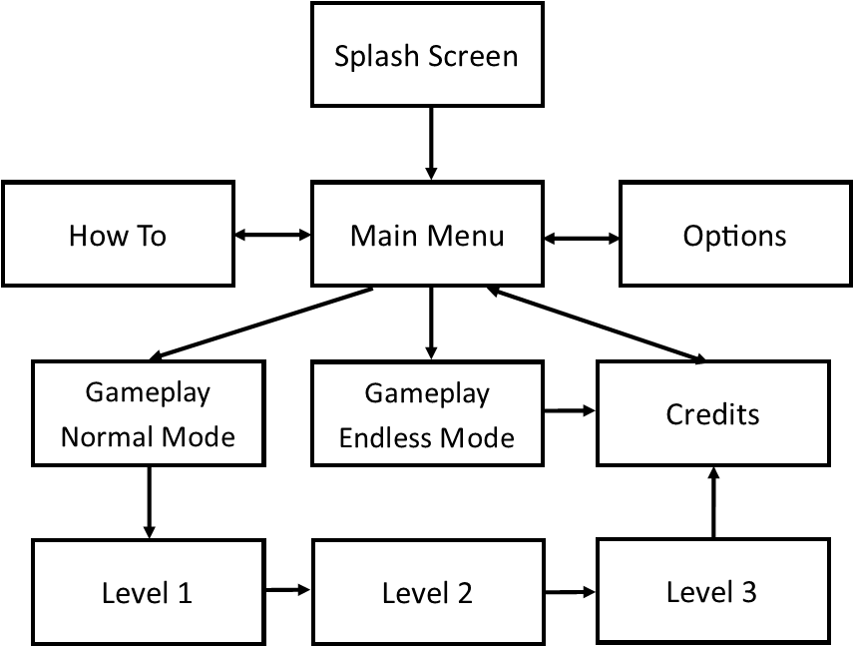

# 10 Game Play

## 10.1 Game Controls (PC)

Press SPACE or ENTER/RETURN or LEFT MOUSE BUTTON to jump

## 10.2 Game Camera

### 10.2.1 HUD

### 10.2.2 Maps

# 11 Players

## 11.1 Characters

## 11.2 Metrics

## 11.3 States

## 11.4 Weapons

# 12 Player Line-up

# 13 NPC

## 13.1 Enemies

### 13.1.1 Enemy States

### 13.1.2 Enemy Spawn Points

## 13.2 Allies / Companions

### 13.2.1 Ally States

### 13.2.2 Ally Spawn Points

# 14 Art

## 14.1 Setting

## 14.2 Level Design

## 14.3 Audio

# 15 Procedurally Generated Content

## 15.1 Environment

## 15.2 Levels

## 15.3 Artificial Intelligence NPC

## 15.4 Visual Arts

## 15.5 Audio

## 15.6 Minimum Viable Product (MVP)

# 16 Wish List